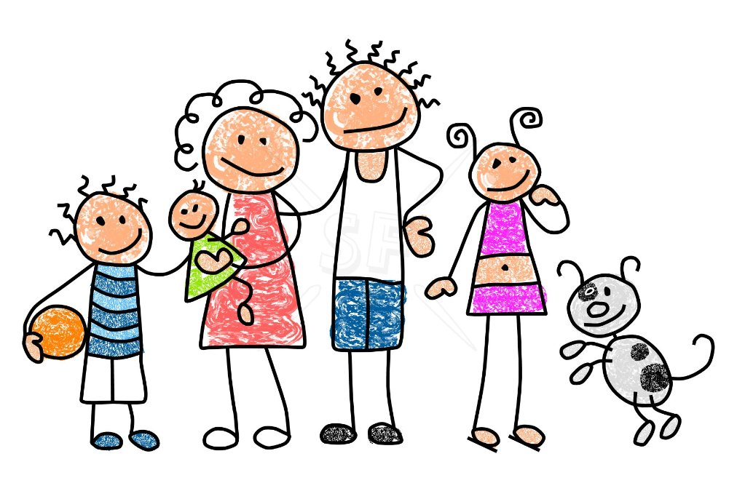
Preschool #102 Newsletter 9/14/16
A Peek At The Week

We are excited to begin to introduce our (OWL) Opening the World of Learning curriculum with our preschool students this week. In Unit One, children will be exploring and talking about families and the many different ways family members relate to and help one another.
In our first story, Oonga Boonga, by Frieda Wishinsky, family members try to soothe Baby Louise. Only her brother Daniel can make her stop crying by saying the words “Oonga boonga” and “Bunka wunka.” In this story the children learn that babies need a lot of care and all family members try to help. We will be asking the children to talk about experiences or people in their families that are like events or characters in the book. The children will be involved with a variety of center activities such as art, block building, exploring books, constructing puzzles, sorting buttons, counting, drawing and dramatic play. We are glad to be involved with a variety of fun and engaging activities that help us learn and grow!

Looking Ahead

Enrichment Classes Begin this week!

Thursday, Sept. 15, 2016 Fall Picture Day Look your Best!
Parent Orientation 6:00-8:00 p.m. REQUIRED FOR ALL PARENTS.

Thursday, September 22, 2016 PSA Fun Lunch

Friday, September 23,2016 No Classes Faculty Meeting

Don’t forget to buy your Monster Cash Raffle Ticket from your child’s teacher!

