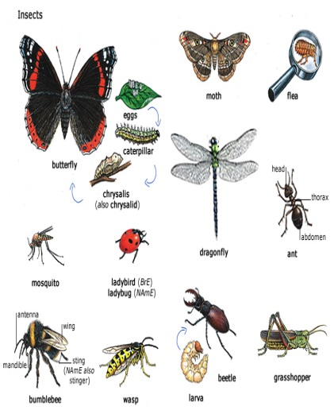
Preschool#102 Newsletter

This summer have your child go bug-gy! Ladybugs, beetles and bees, oh my! Preschoolers love learning about insects and spiders! Ask your child their thoughts or questions about bugs, their behavior, and their habitats. Learn about the parts of an insect and exploring some of the different species of insects to learn about. You will learn that bugs can crawl, run, jump, fly and even swim! Bugs have been around for a very long time. The first land-dwelling bugs probably lived 395 million years ago-there are fossils of tiny mites from this time! Bugs make a perfect topic of study for preschoolers. Not only are young children naturally interested in them, but you can simply head outdoors and observe them up close. This summer, visit the library, and take out some fiction and non-fiction books to read with your child. Go on a nature walk, and count how many different species you observed. Visit the Peggy Notebaert Nature museum, or simply take a walk in the forest preserves or your local park. Rent a movie from the library about insects. Go to the dollar store and purchase plastic insects for your child to play with in the sand, or in the grass in your own backyard. Have your child draw and write or dictate a story about them. Make an insect craft, like a caterpillar out of pom-poms. There are many inexpensive ways to engage your child in learning about this fascinating topic and it provides the opportunity to cover basic science concepts and skills such as classification, observation and responses to habitat. Enjoy the beautiful summer season with your child and learn to appreciate the amazing variety of insects God has created on our beautiful planet!

Looking Ahead

Remember to follow the PJPII “Warrior Way “this summer. Be Ready, Responsible and Respectful, in all you say and do. Your positive behavior will help you learn new things, develop your self-confidence and show your community that you have amazing abilities!
We wish to extend our thanks, for your help and cooperation, this past school year. May God bless you and keep you in His loving care, and we look forward to seeing you at PJPII School in August! Have a Spectacular Summer!

