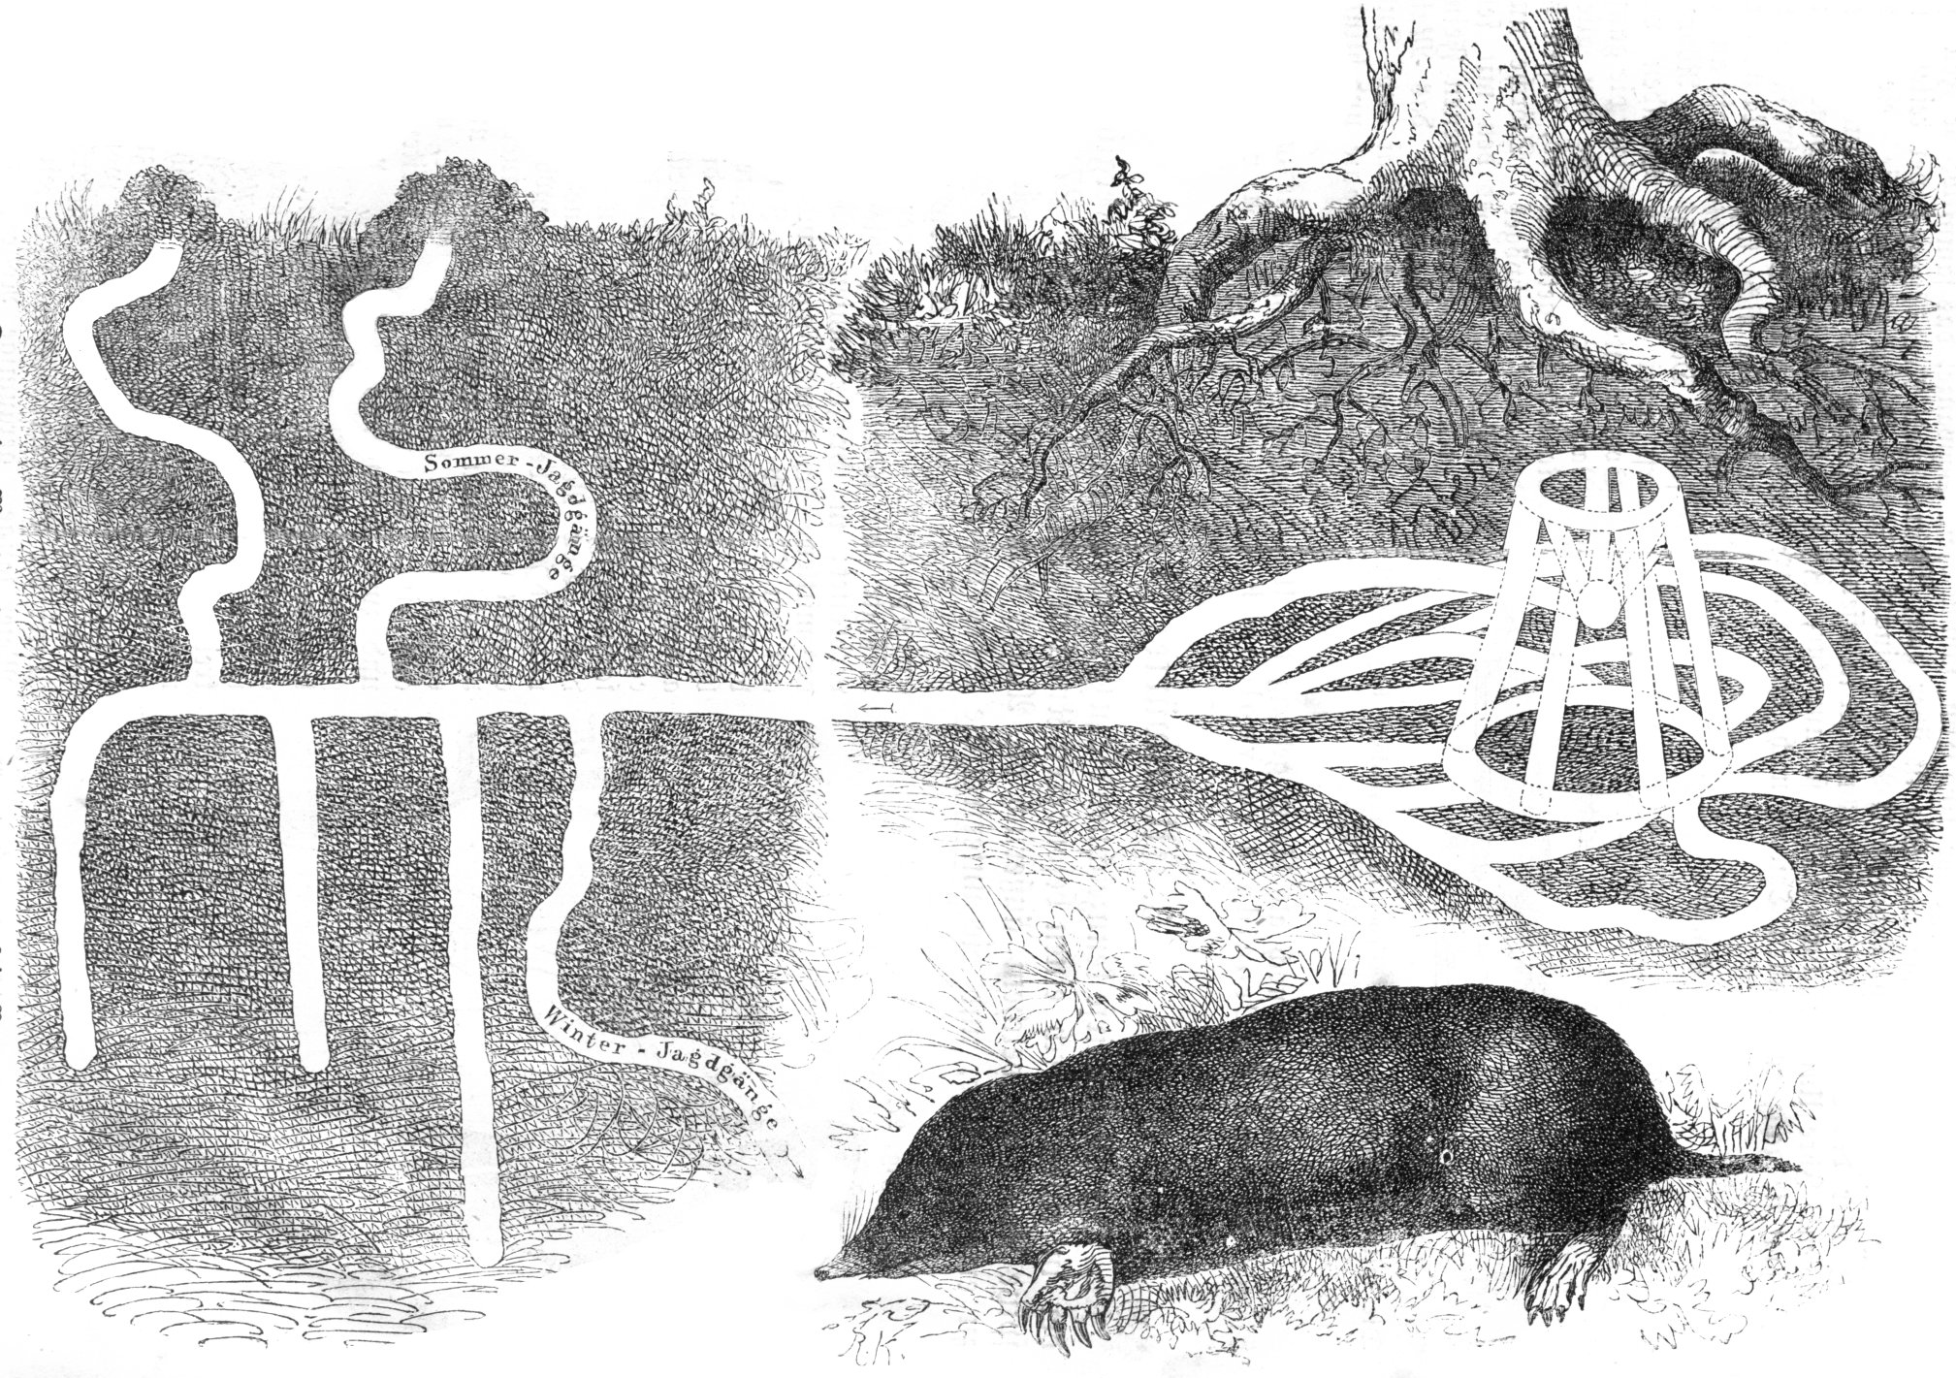
Preschool #102 Newsletter
A Peek At The Week

We are continuing our exploration of “Things That Grow.” We are talking about the fact that homes are for shelter and safety and that animals build their homes in different places. We are making connections to some of the animal’s homes that we have read about in previous stories, like the lion who lived in a cave and the bird that built a nest in a tree outside the lion’s cave in the story, “The Lion and the Little Red Bird.” We have been discussing worm and snail habitats and other mammals that burrow underground and make tunnels for their home like the mole, gopher, groundhog rabbit, chipmunks, and snakes. The students’ are learning to differentiate between animals that make their homes in water, in trees and on and under dry land. God has created a marvelous world for us to explore and enjoy!

Looking Ahead

Please make sure that you work on your child’s End of the Year Ceremony’s project regarding your child’s favorite book. Due date: May 25, 2017. Remember you can decorate your project with your child’s photographs. All projects will be given back after our ceremony.

Please note: Our End of the Year Ceremony on Thursday, June 8, 2017 will be held at 10:00 a.m. not 10:30. There was a mistake on the school calendar. Letters will be sent home soon with more information about our celebration.

