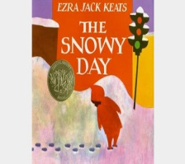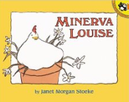
Preschool #102 Newsletter
We are happy to be back in school learning and exploring with our friends after our Winter Break. We are reviewing some wonderful stories about the beautiful season of winter in two of our story selections in this final unit. In our first story, Peter wakes up one morning to find a snow-covered world outside his window. He explores the wintry landscape, entertaining himself with the snow. He brings a snowball home and is sad when it melts. But the next day, there’s more snow outside to enjoy! In our next book selection, we meet a daring chicken named Minerva Louise who ventures outside in the snow while the other chickens stay in the coop. Minerva Louise makes several humorous mistakes as she looks for a scarf, shoes, and hat to keep herself warm. We have asked the children Have you ever wanted to do something, but no one else was interested? Did you decide to do it or did you go ahead and do it yourself the way Minerva Louise did? Children learn complicated new ideas when they have many opportunities to talk about the wind, water and evaporation.
Looking Ahead
Monday, January 16, 2017 Martin Luther King, Jr. Day/No School
Monday, January 23, 2017 1:00 Dismissal/Faculty Meeting
Week of January 16-20 After School Enrichment Begins!
Sunday, January 29, 2017 School Mass at FHM 9:00 a.m.
Science Fair After Mass

